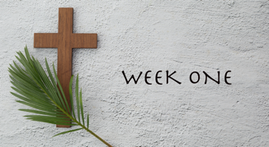

Action Plan - The two photographs page 7 of “Conversations with Our Awesome God”

As suggested, play some gentle instrumental music

Spend some time examining one photograph and then the same amount of time examining the other.

While you look at the Jericho photograph, reflect on:

“The barrenness”. When have you been through a barren time? How did you cope?

You will see a road, what will lead you on. What did you learn about yourself and about God as you moved on, moved though the valley?

Many people have been able to come closer to God in the desert or wilderness. In this great land of ours there are many dry and barren places. Have you been there and what have you learnt?

Now reflect on the basket of fruit - it looks so fresh, so inviting.

Do we give thanks for the joy of abundant food? Do we give thanks for those who have grown and distributed the food?

There is an unjust distribution of food in the world. What can can we do to address this imbalance?

Other considerations:

Yes, we may walk through the wilderness from time to time, but there are some whose life is engulfed by being the wilderness. What can we do as a Church to reach out to our neighbour, to those who is struggling with living in the wilderness due to domestic violence, mental illness and loneliness?

Is there some action your faith community could undertake to address some of the issues that society faces?

